**Binary Search**

Binary search is a search algorithm that finds the position of a target value within a sorted array.

1. **Problem solving:**

**Initialization:**

Start with the entire sorted array.

Set two pointers, low and high, to the beginning and end of the array, respectively.

**Middle Element:**

Calculate the middle index as mid = Math.floor((low + high) / 2).

**Comparison:**

Compare the middle element with the target value.

If the middle element is equal to the target, the search is successful, and return the index.

If the target is less than the middle element, update high = mid - 1 to search in the left half.

If the target is greater than the middle element, update low = mid + 1 to search in the right half.

**Repeat:**

Repeat steps 2-3 until the target is found or the low pointer is greater than the high pointer.

**Result:**

If the target is found, return its index; otherwise, return -1 indicating that the target is not in the array.

1. **Flow chart**

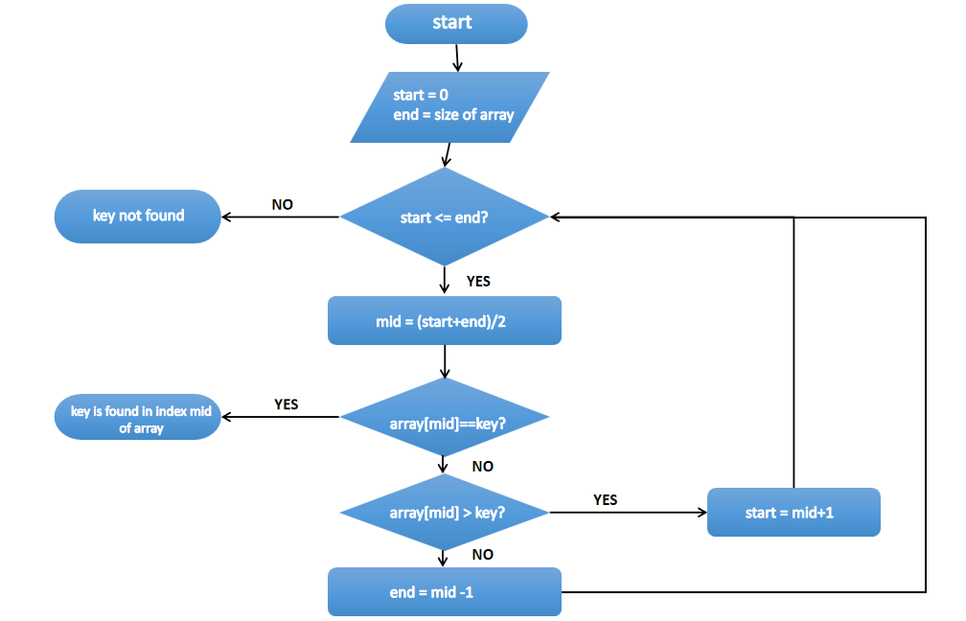

1. **Output**

